🔐 NetworkWalks Cybersecurity Internship — Week 3
Password Cracking & Hash Analysis Lab

Author: Adewuyi Wakeel
Date: September 2026
Project Track: W3-PM1 & W3-PM2 Mandatory Modules
Cybersecurity Intern: Networkwalks Batch B083

📌 Project Overview

This repository documents the Week 3 project work completed by me as part of the NetworkWalks Cybersecurity Internship.
The official Week 3 project sheet lists two mandatory modules:
- W3-PM1: Password Cracking with JTR (John the Ripper)
- W3-PM2: Password Cracking with NW Tools

Per the internship requirements, both essential modules were successfully completed and are documented below.
Scope & Compliance: All password-recovery activities documented here were performed by Adewuyi Wakeel against the provided training PDFs in a controlled internship lab environment.

🎯 Objectives
- Understand the basic process of password cracking.
- Extract password hashes from protected PDF files.
- Use password-cracking tools to test password candidates against hashes.
- Understand the role of dictionaries and wordlists.
- Gain practical experience with John the Ripper/Johnny.
- Troubleshoot issues encountered during the practical.
- Successfully recover the passwords for all three authorized PDF files.
- Document the process and results for my cybersecurity portfolio.

🛠️ Tools & Resources
Tool / Resource | Purpose
Networkwalks Hash Calculator | Web-based lab utility used to extract PDF hashes via browser
Networkwalks Password Cracker | Web-based lab utility used for the dictionary attack demonstration
John the Ripper (JTR) | Command-line engine used for dictionary-based password recovery
Johnny | Graphical interface for John the Ripper
rockyou.txt | Standard security wordlist used for the dictionary attack
Windows-Lab | Security testing environment and OS platform

🔄 Password Cracking Workflow
The practical followed this general workflow:
Protected PDF
↓
Hash Calculator
↓
PDF Hash ($pdf$...)
↓
Password Dictionary / Wordlist
↓
Password Cracker
↓
Recovered Password

🔎 Part 1 — Extracting the PDF Hash
The first stage was to obtain the password hash from each protected PDF.
The protected PDF files were provided as part of the Networkwalks internship exercise.
I used the Networkwalks Hash Calculator to process the files and obtain their corresponding PDF hashes, which began with $pdf$.
The complete hash was then used as the input for the password-cracking stage.

Evidence
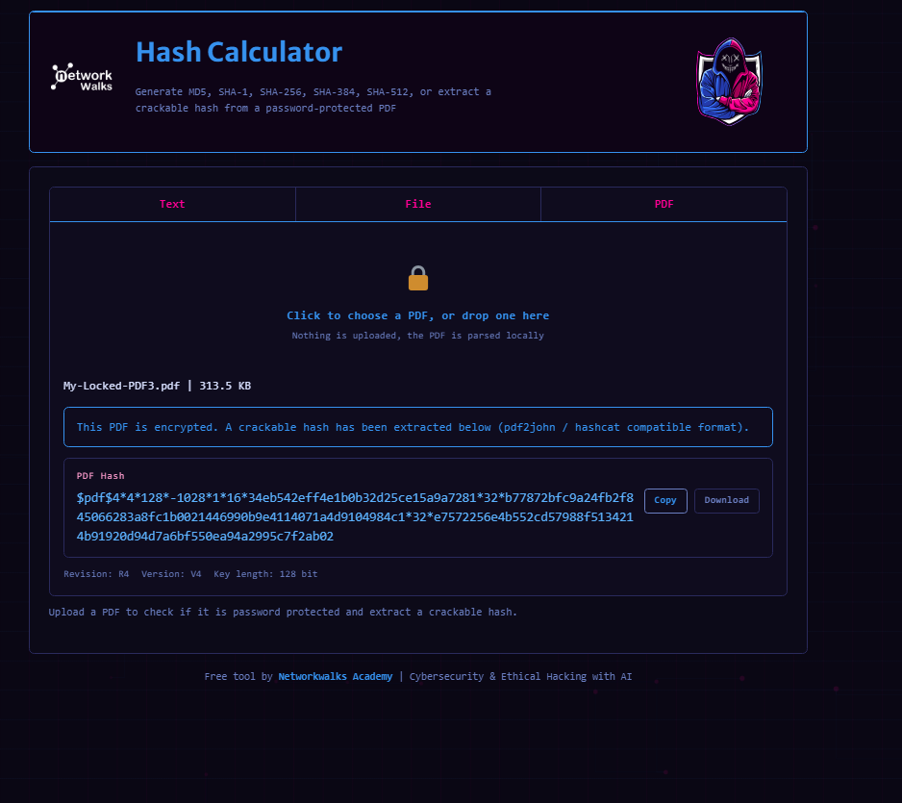

💻 Part 2 — Attempting John the Ripper / Johnny
I initially decided to try John the Ripper/Johnny before moving to the Networkwalks web-based Password Cracker.
After downloading and setting up the software, I encountered issues with the directory and path configuration.
The folder structure on my laptop was different from the path shown in the internship guidelines, so I initially had difficulty determining the correct configuration.
I later changed the directory configuration to point directly to the program files. This caused unexpected behavior, with Johnny repeatedly opening new instances whenever I attempted to launch or reload it.
Eventually, the repeated launches became difficult to control, so I had to shut down my laptop.
When I later tried the hash-text workflow again, starting the attack caused another Johnny instance to open.
Rather than continue with a configuration I was no longer confident in, I decided to switch to the Networkwalks-provided tools.

Evidence
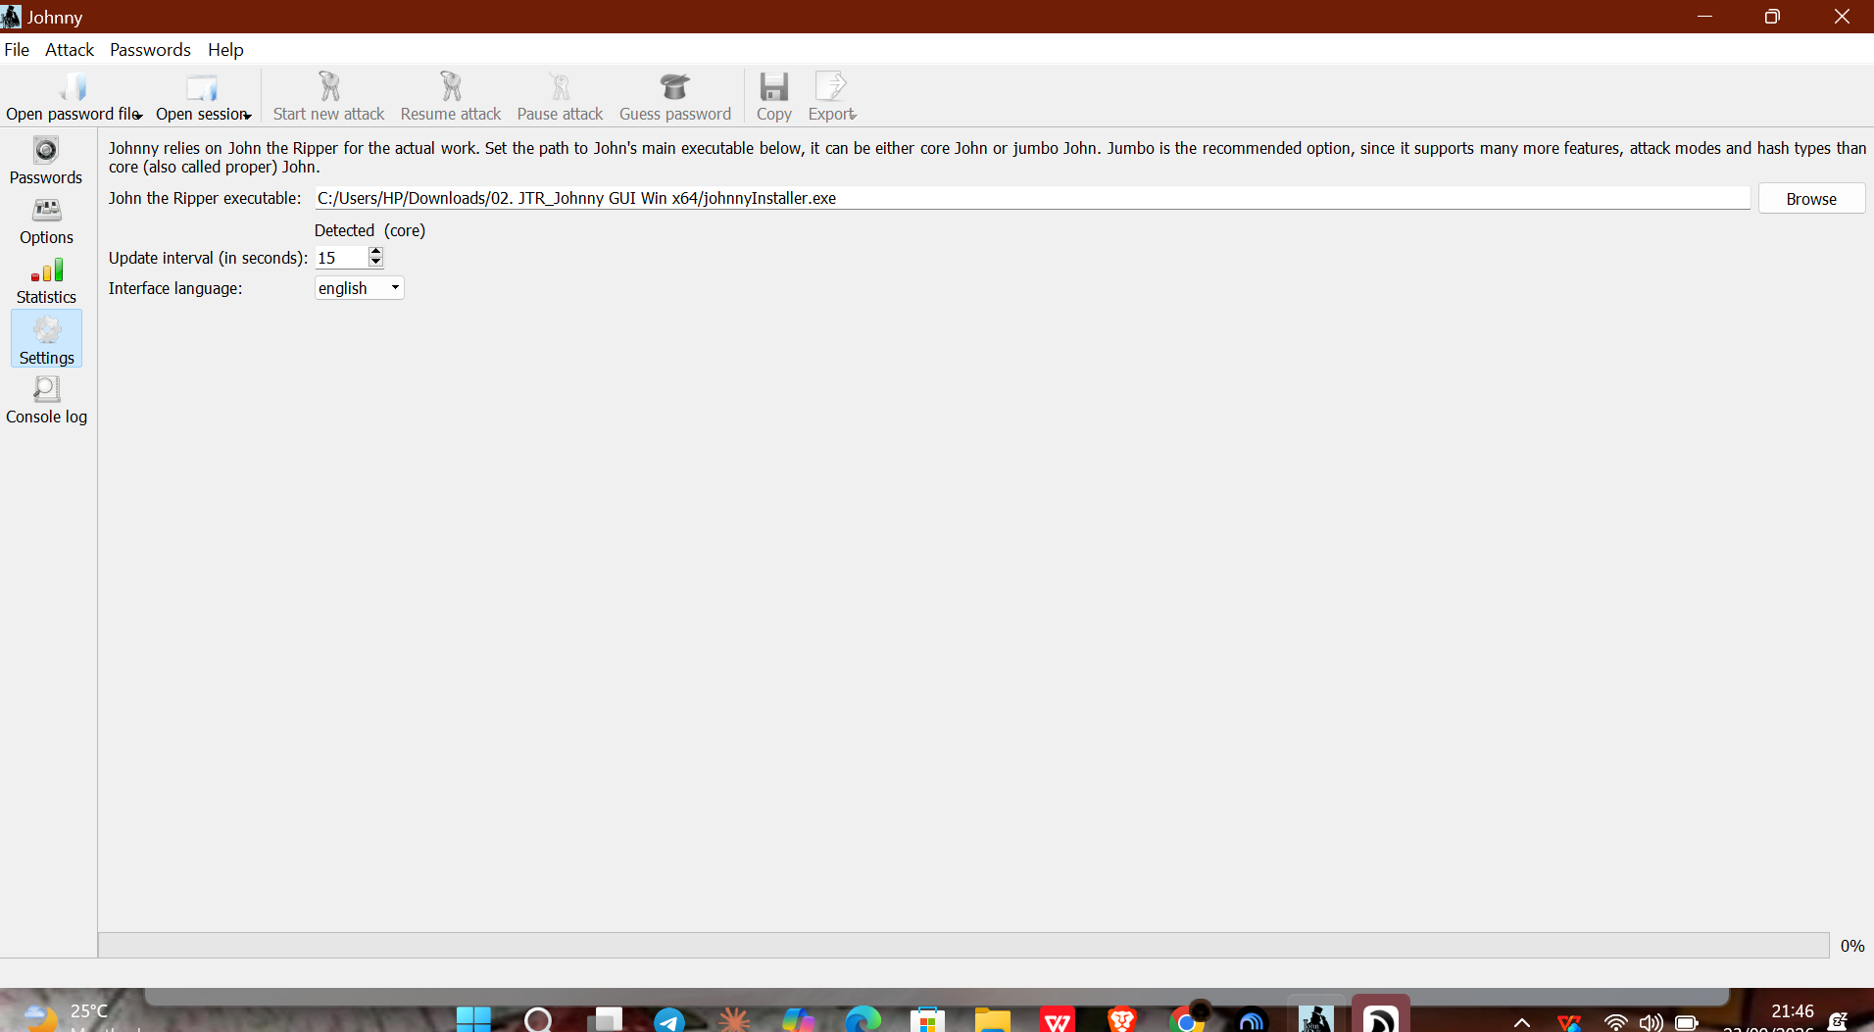

🌐 Part 3 — Using the Networkwalks Password Cracker
I then moved to the password-cracking tools provided by Networkwalks.
My first attempt used the smaller dictionary available through the Networkwalks Password Cracker.
The dictionary contained approximately 100 common words.
The passwords for the protected PDFs were not recovered using this initial dictionary.
This was an important point in the practical because it showed me that having a password-cracking tool is not enough on its own. The quality and size of the wordlist can have a major effect on the outcome.

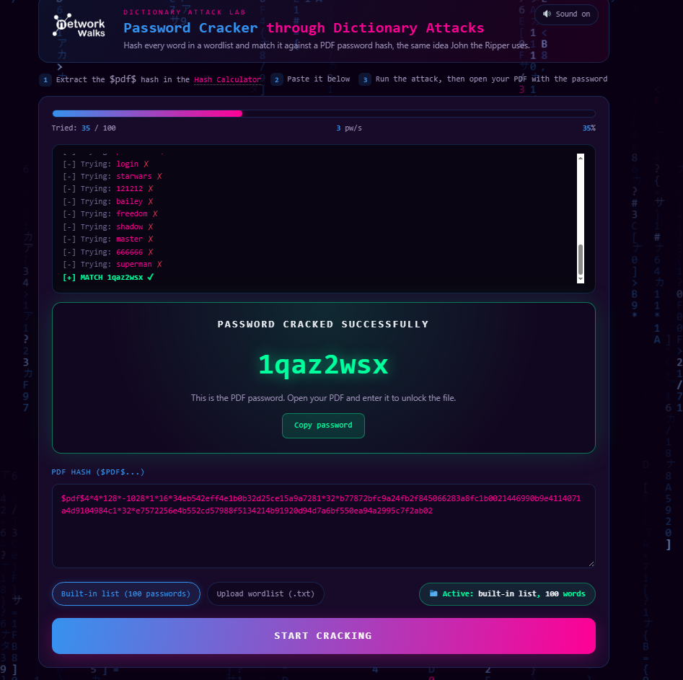

✅ Part 5 — Password Recovery
Using the larger wordlist, I successfully recovered the passwords for all three protected PDF files.
PDF | Result
PDF 1 | ✅ Password recovered
PDF 2 | ✅ Password recovered
PDF 3 | ✅ Password recovered

Evidence


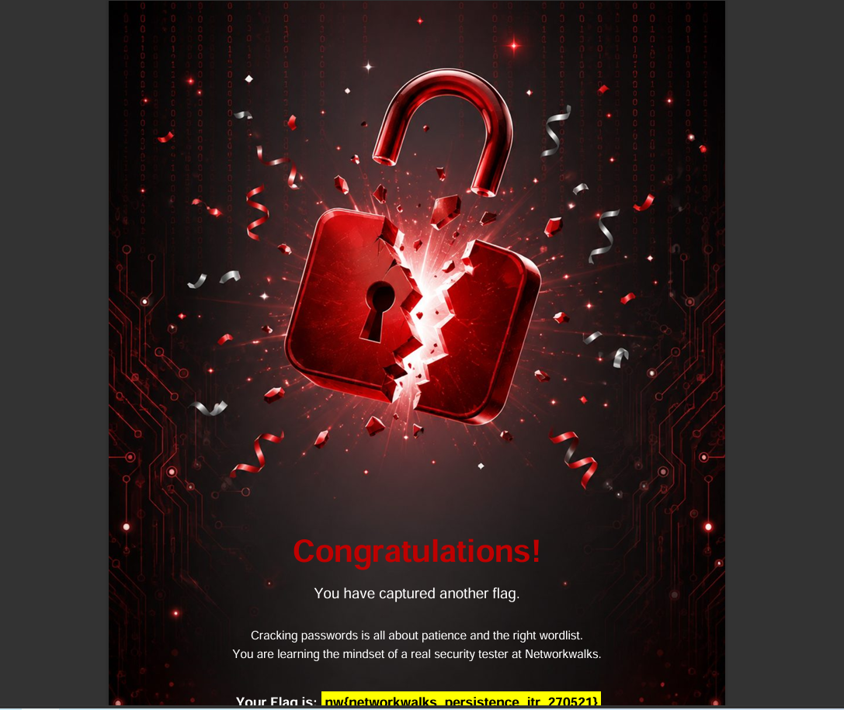



🛠️ Challenges & Troubleshooting

1. John the Ripper / Johnny path configuration
My first challenge was getting the correct directory/path configuration for Johnny because the folder structure on my laptop differed from the example in the internship guidelines.

2. Repeated Johnny instances
After changing the path configuration, Johnny repeatedly opened new instances when I attempted to launch or reload it.
This eventually required me to shut down my laptop before continuing with the practical.

3. The initial dictionary matched
The first Networkwalks Password Cracker attempt used a dictionary of approximately 100 common words, but it was enough to recover the passwords.

🧠 What I Learned

🔐 1. Password Hashes are different from Passwords
A protected file can use a hash representation of its password rather than storing the password in plain text.
The cracking process works by testing password candidates and checking whether they correspond to the target hash.

🛠️ 2. Troubleshooting is part of cybersecurity
My first approach with John the Ripper/Johnny did not go as planned.
Instead of continuing with a configuration I could no longer confidently troubleshoot, I reviewed the available resources and moved to another authorized method.

💻 3. Practical cybersecurity requires adaptability
The exercise looked straightforward when I first read the instructions, but actually doing it introduced configuration problems and unexpected software behavior.
I learned that practical cybersecurity work is not always about getting the first tool to work. Sometimes, understanding the problem, troubleshooting it, and choosing an appropriate alternative is just as important.

📸 Evidence
Screenshots from the practical are included in the screenshots/ directory.

⚠️ Scope & Authorization
This practical was completed as part of the Networkwalks Cybersecurity Internship using files and resources provided for the authorized training exercise.
The password-cracking activities documented in this repository were performed only within the scope of the internship lab.

📝 Conclusion
Week 3 gave me my first practical experience with password cracking.
My initial attempt with John the Ripper/Johnny came with configuration and application issues, but switching approaches and working with a larger wordlist eventually allowed me to successfully recover the passwords for all three protected PDFs.
More importantly, the exercise helped me understand the relationship between protected files, hashes, password candidates, dictionaries, and wordlists.
It also reminded me that cybersecurity is not always about getting everything right on the first try. Troubleshooting, researching, adapting, and documenting what went wrong are all part of the learning process.

